Supplementary Materials 1

Trophic niche partitioning in giant clams

**Summary:**

**Materials and Methods**

Sample collection (Fig. 1)

Habitat assessment (Fig. 2)

**Results**

Stable isotope analysis (Table 1-3, Fig. 3)

Symbiodiniaceae diversity and community structure (Fig. 4)

Phylogenetic signal analysis (Fig. 5)

**Discussion**

Geographic distribution of the 6 giant clams species of interest (Fig. 6)

**Other Supplementary Materials for this manuscript include the following:**

Data S2 to S5

**Materials and Methods**

Sample collection

Giant clam cohorts were raised at the hatchery in open-circuit raceways with coarse filtered seawater pumped from the Tabunan lagoon (Semirara Island, Philippines, 12°05'13.62" N, 121°20'45.66" E) before being transferred to sandy areas of the lagoon at 2-5 m depth (Supplementary Fig. 1). Five of the six giant clam species (*Tridacna gigas*, *Tridacna derasa*, *Hippopus porcellanus*, *Hippopus hippopus* and *Tridacna squamosa*) were sampled in the north of the lagoon while the *Tridacna maxima* samples were collected less than 400 m away in the southwest of the lagoon. The samples from the five species in the north were collected from a 30 m2 area and the *Tridacna maxima* from a 10 m2 area. To ensure that both areas had similar conditions, light and temperature hobo loggers were deployed in November 2019. All the samples for SIA analysis were collected across three days in November 2019. Each mantle was clamped ~0.5 cm from the edge using sterile hemostat forceps and sterile surgical scissors. Mean wet mass of clips varied from 0.095±0.035 g (*T. derasa*; ±SD) to 0.177±0.046 g (*H. porcellanus*). On each sampling day, duplicate samples of 3 L of seawater from the Tabunan lagoon were collected and filtered through two 47 mm glass fiber filters (GFF pore size 0.45 μM) to collect particulate organic matter. All the filters were placed in a petri dish and dried at ambient temperature before analysis. Mantle clips collected for symbiont community analysis came from giant clams sampled in the Philippines. While initially all samples for symbiont community analysis were from Semirara Island, *T. derasa* and *T. squamosa* samples did not pass library QC, leading to data analysis from hatchery-bred individuals reared at the Silaqui ocean nursery of the University of the Philippines Bolinao Marine Laboratory (Bolinao, Pangasinan, Philippines; Supplementary 3).



**Supplementary Figure 1**: Map of the study site highlighting Semirara Island and the Tabunan lagoon. Picture: Isis Guibert.

Habitat assessment

Light intensity and temperature were highly similar in both areas of the Tabunan lagoon (Supplementary Fig. 2). Visual observations showed that both areas were characterized by sandy sediment, 2-5 m depth and patches of seagrass around the sampled areas.



**Supplementary Figure 2.** Environmental conditions in the two sampled areas sampled in the Tabunan Lagoon in November. Light intensity (A) and temperature (B) were recorded in the north Tabunan lagoon (red) and the south Tabunan lagoon (blue).

**Results**

Stable isotope analysis

**Supplementary Table 1.** Summary statistics of stable isotope analysis of paired clam host and algal symbiont samples. Mean (±SD) carbon to nitrogen ratio (C:N), carbon (*δ*13C) and nitrogen (*δ*15N) stable isotope values, and difference between host and symbiont isotope values (Δ13C and Δ15N) of six giant clam species collected from Cover Bay, Semirara Island, Philippines.

|  |  |  |  |  |  |  |  |  |  |
| --- | --- | --- | --- | --- | --- | --- | --- | --- | --- |
| **Species** | **n** | **C:N** | | ***δ*13C (‰)** | | ***δ*15N (‰)** | | **Δ13C (‰)** | **Δ15N (‰)** |
|  |  | **Host** | **Symb** | **Host** | **Sym** | **Host** | **Sym** |
| *T. gigas* | 27 | 5.7±1.3 | 5.7±1.3 | -14.4±1.2 | -15.0±1.1 | 4.9±0.3 | 4.9±0.1 | 0.5±0.5 | 0.1±0.3 |
| *T. derasa* | 28 | 5.6±1.4 | 6.0±0.7 | -12.3±0.9 | -13.1±0.7 | 4.7±0.3 | 4.3±0.2 | 0.8±0.7 | 0.4±0.3 |
| *H. porcellanus* | 23 | 6.0±0.7 | 5.7±0.3 | -16.7±0.4 | -17.8±0.5 | 4.8±0.1 | 4.4±0.3 | 1.1±0.4 | 0.4±0.3 |
| *T. maxima* | 9 | 7.0±2.2 | 6.4±1.5 | -17.7±0.7 | -18.9±0.9 | 4.7±0.2 | 4.2±0.2 | 1.2±0.9 | 0.5±0.3 |
| *H. hippopus* | 25 | 5.5±1.2 | 5.5±0.5 | -15.2±0.9 | -16.5±0.8 | 5.2±0.3 | 4.4±0.4 | 1.3±0.6 | 0.8±0.4 |
| *T. squamosa* | 26 | 4.8±1.7 | 6.1±0.6 | -14.9±1.3 | -16.7±1.4 | 5.0±0.3 | 4.2±0.3 | 1.7±0.9 | 0.7±0.3 |

**Supplementary Table 2.** Standard ellipses areas and overlap metrics of six giant clam hosts and their associated algal symbionts in isotopic space. Stable Isotope Bayesian Ellipses in R (SIBER) analysis was used to fit standard ellipses area corrected for sample size (SEA*C*) that captured 40 % of the variation of the data to host (Host SEA*C*) and symbiont (Symbiont SEA*C*) isotope values. The mode of the last 100 posterior ellipses from a Bayesian generated distribution was used as to compute the Bayesian standard ellipse area of the host group (Host SEA*B*), the symbiont group (Symbiont SEA*B*), and the area of overlap between the two. The area of overlap of host and symbiont was expressed as a proportion of Host SEA*B* (SEA*B*H) and Symbiont SEA*B* (SEA*B*S).

|  |  |  |  |  |  |  |  |  |
| --- | --- | --- | --- | --- | --- | --- | --- | --- |
| **Species** | **Host SEAC (‰2)** | **Host SEAB (‰2)** | **Symbiont SEAC (‰2)** | **Symbiont SEAB (‰2)** | **SEA*C* area of overlap (‰2)** | **EA*B* area of overlap (‰2)** | **SEABH** | **SEABS** |
| *T. gigas* | 1.19 | 1.13 | 0.43 | 0.41 | 0.40 | 0.29 | 0.24 | 0.90 |
| *T. derasa* | 0.60 | 0.59 | 0.34 | 0.32 | 0.10 | 0.00 | 0.00 | 0.00 |
| *H. porcellanus* | 0.14 | 0.14 | 0.39 | 0.37 | 0.00 | 0.00 | 0.00 | 0.00 |
| *T. maxima* | 0.51 | 0.41 | 0.73 | 0.60 | 0.00 | 0.00 | 0.00 | 0.00 |
| *H. hippopus* | 0.70 | 0.65 | 0.93 | 0.88 | 0.00 | 0.00 | 0.00 | 0.00 |
| *T. squamosa* | 0.95 | 0.87 | 0.89 | 0.86 | 0.00 | 0.00 | 0.00 | 0.00 |

**Supplementary Table 3.** Comparison of the placement and overlap in isotopic space of six giant clam hosts and their associated algal symbionts. Host and symbiont placements were assessed by measuring the distance between the ellipse centroids of the two groups (DEC) and running a residual permutation procedure (RPP). Host and symbionts occupied distinct space on the isotopic biplot when p<0.05. Overlap between the two groups was assessed using a Bayesian analysis to generate a posterior distribution of ellipses fit to encompass 95 % of the variation of each group. The mode of the last 100 posterior ellipses and their overlap was used as the Bayesian ellipse area of the host group (Host MEA*B*), the symbiont group (Symbiont MEA*B*), and the area of overlap between the two. The proportion of host and symbiont MEA*B* overlapping that of the other was also calculated (respectively, MEA*B*H and MEA*B*S).

|  |  |  |  |  |  |  |  |
| --- | --- | --- | --- | --- | --- | --- | --- |
| **Species** | **DEC (‰)** | **RPP**  **p-value** | **Host MEAB (‰2)** | **Symbiont MEAB (‰2)** | **Area of overlap (‰2)** | **MEABH** | **MEABS** |
| *T. gigas* | 0.50 | 0.116 | 6.97 | 2.61 | 2.31 | 0.32 | 0.98 |
| *T. derasa* | 0.93 | <0.001 | 3.65 | 2.02 | 1.63 | 0.41 | 0.82 |
| *H. porcellanus* | 1.14 | <0.001 | 0.78 | 2.15 | 0.41 | 0.49 | 0.17 |
| *T. maxima* | 1.27 | <0.001 | 2.37 | 3.97 | 0.82 | 0.24 | 0.20 |
| *H. hippopus* | 1.57 | <0.001 | 4.05 | 5.28 | 2.01 | 0.43 | 0.34 |
| *T. squamosa* | 1.89 | <0.001 | 5.56 | 5.26 | 1.42 | 0.28 | 0.31 |

**Supplementary Table 4.** Results of post-hoc pairwise comparisons between giant clam species using either a Games-Howell Post-hoc test for non-normal, heteroscedastic *δ*13C values or a Tukey’s HSD test for normal, homoscedastic *δ*15N values.

|  |  |  |
| --- | --- | --- |
| **Comparison** | ***δ*13C P-values**  **(Games-Howel post hoc)** | ***δ*15N P-values**  **(Tukey’s HSD)** |
| *T. gigas* x *T. derasa* | 0.253 | 0.0071009 |
| *T. gigas* x *H. porcellanus* | 0.000887 | 0.0144326 |
| *T. gigas* x *T. maxima* | 0.378 | 0.0128298 |
| *T. gigas* x *H. hippopus* | 0.0000456 | 0.0000000 |
| *T. gigas* x *T. squamosa* | 0.00000266 | 0.0000000 |
| *T. derasa* x *H. porcellanus* | 0.663 | 1.0000000 |
| *T. derasa* x *T. maxima* | 0.918 | 0.9506383 |
| *T. derasa* x *H. hippopus* | 0.067 | 0.0003557 |
| *T. derasa* x *T. squamosa* | 0.001 | 0.0028053 |
| *H. porcellanus* x *T. maxima* | 1.000 | 0.9479829 |
| *H. porcellanus* x *H. hippopus* | 0.486 | 0.0006674 |
| *H. porcellanus* x *T. squamosa* | 0.015 | 0.0045442 |
| *T. maxima* x *H. hippopus* | 0.994 | 0.2335922 |
| *T. maxima* x *T. squamosa* | 0.599 | 0.4599928 |
| *H. hippopus* x *T. squamosa* | 0.436 | 0.9920773 |

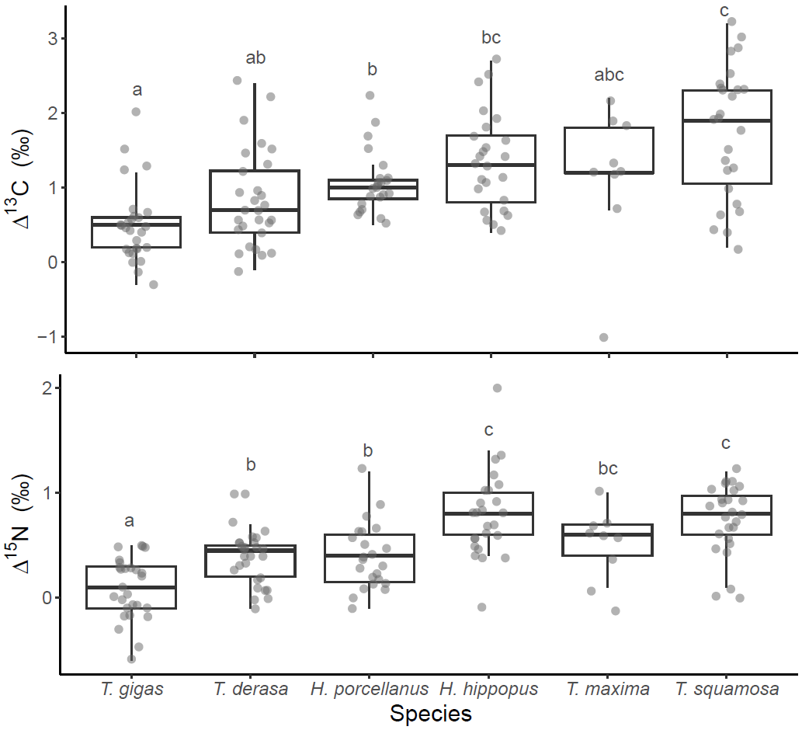**Supplementary Figure 3.** Δ13C (*δ*13CHost-*δ*13CSymbiont; **A**) and Δ15N (*δ*15NHost-*δ*15NSymbiont; **B**) of each giant clam species. Boxplots show the median and interquartile range; individual data are shown with grey points. Species labeled with one or more of the same letters are not significantly different (e.g. “a” and “ab” share the letter “a” and are thus not significantly different from one another). In contrast, species with labels that do not share any common letters are significantly different from one another (e.g. “a” is significantly different from “b”) as determined through pairwise comparisons (Δ13C: Games-Howel post hoc tests; Δ15N: Tukey’s HSD tests). P-values for each pairwise comparison are provided in Supplementary Table 4.

Symbiodiniaceae diversity and community structure

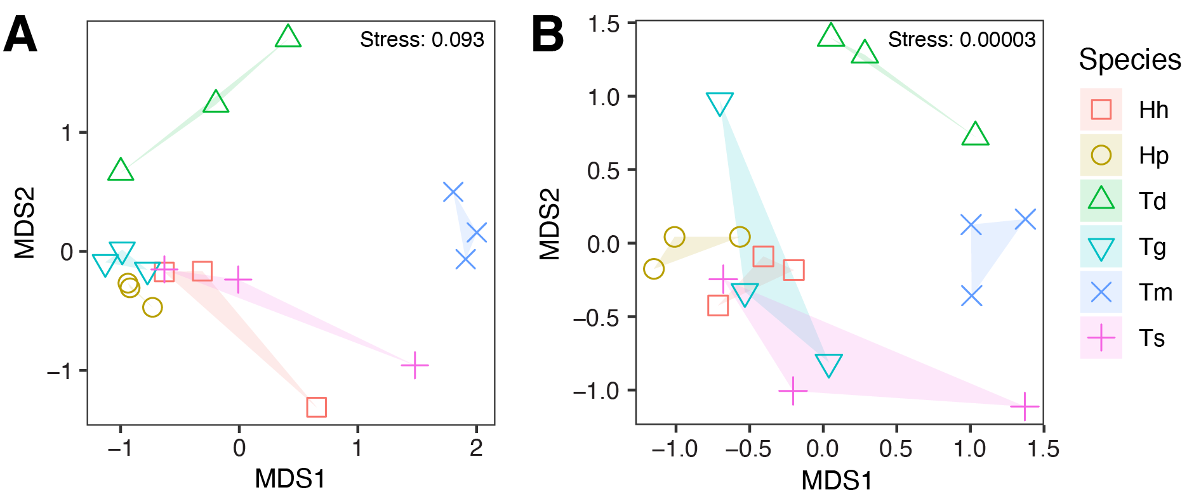

**Supplementary Figure 4**. Non-metric multi-dimensional scaling plots of the Symbiodiniaceae community composition in six giant clams species, based on Bray-Curtis dissimilarities. Ordinations are shown for (A) ITS2 sequences and (B) ITS2 type profiles. For each species, three replicate samples are represented by distinct symbols and colors, with points connected and enclosed by shaded polygons to illustrate within-species variation. Species are denoted as follows: *Hippopus hippopus* (Hh, red squares), *Hippopus porcellanus* (Hp, brown circles), *Tridacna derasa* (Td, upward-pointing green triangles), *Tridacna gigas* (Tg, downward-pointing turquoise triangles), *Tridacna maxima* (Tm, blue crosses), and *Tridacna squamosa* (Ts, pink upright crosses).

Ordination are based on (A) ITS2 sequences and (B) ITS2 type profiles of six giant clam species: *Hippopus hippopus (Hh), Hippopus porcellanus (Hp), Tridacna derasa (Td), Tridacna gigas (Tg), Tridacna maxima (Tm),* and *Tridacna squamosa (Ts).*

Phylogenetic signal analysis

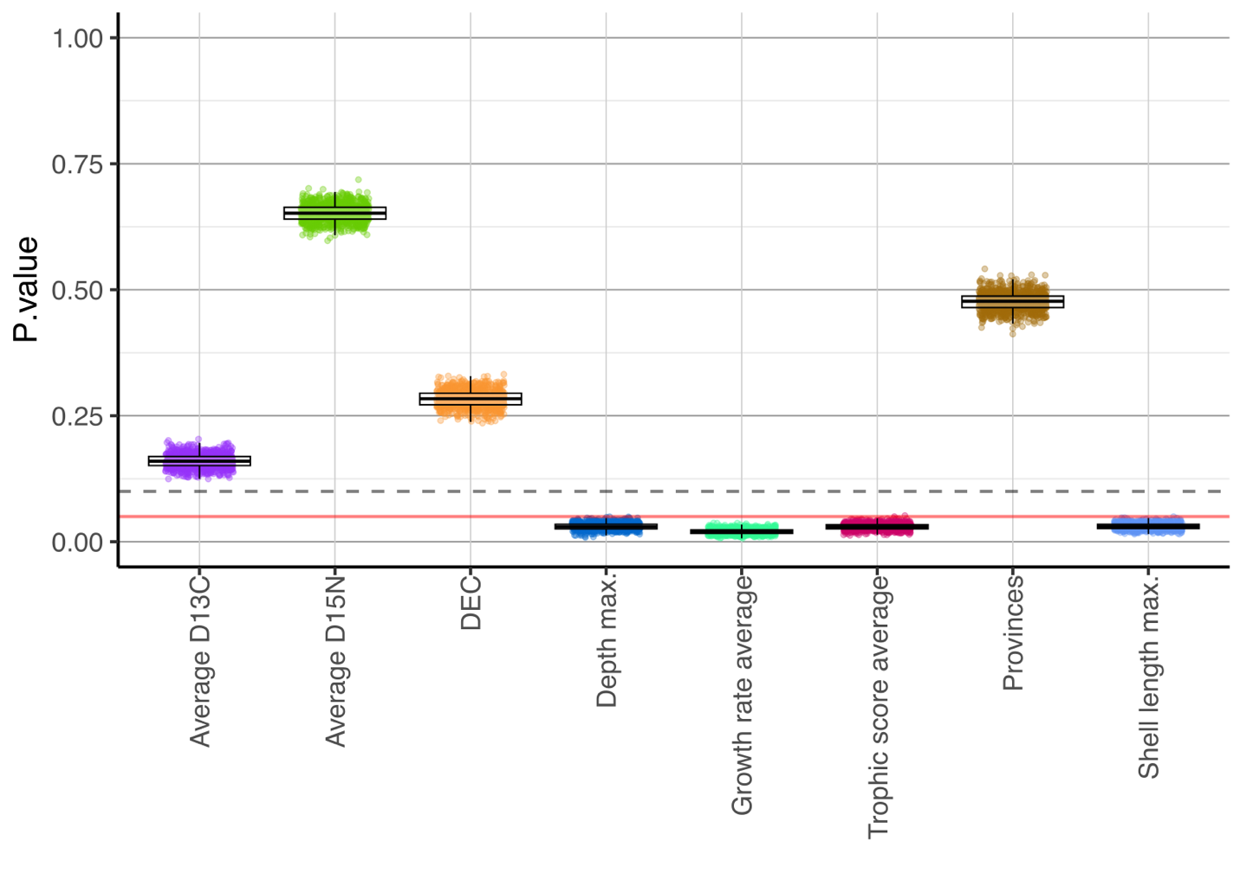**Supplementary Figure 5**. P-values of the eight ecological traits assessed for the phylogenetic signal analysis highlighting four significant traits: maximum depth, growth rate average, trophic niche score, and maximum shell length. Each ecological trait is represented by 1,000 individual p-values, shown as color-coded circles: Average D13C (purple), Average D15N (green), distance between the ellipse centroids DEC (orange), maximum depth (dark blue), growth average rate (light green), trophic niche score average (red), provinces (brown) and maximum shell length (light blue). The boxplot displays the median and the first and third quartiles of the 1,000 results for each trait. Whiskers extend to 1.5 times the interquartile range from the quartiles, and values beyond this range are plotted as outliers.

**Discussion**



**Supplementary Figure 6.** Geographic distribution of the 6 giant clam species of interest. Orange: *Hippopus porcellanus*, blue: *Hippopus hippopus*, Yellow: *Tridacna squamosa*, Green: *Tridacna maxima*, Purple: *Tridacna derasa*, Red: *Tridana gigas*. Location data were obtained from Neo et al. 2017 [4].

**Supplementary References:**

1. Schloss PD, Westcott SL, Ryabin T, Hall JR, Hartmann M, Hollister EB, et al. Introducing mothur: Open-source, platform-independent, community-supported software for describing and comparing microbial communities. Appl Environ Microbiol. 2009;75:7537–41.

2. Camacho C, Coulouris G, Avagyan V, Ma N, Papadopoulos J, Bealer K, et al. BLAST+: architecture and applications. BMC Bioinformatics [Internet]. 2009 [cited 2017 Nov 7];10:421. Available from: http://www.ncbi.nlm.nih.gov/pubmed/20003500

3. Eren AM, Morrison HG, Lescault PJ, Reveillaud J, Vineis JH, Sogin ML. Minimum entropy decomposition: Unsupervised oligotyping for sensitive partitioning of high-throughput marker gene sequences. ISME Journal [Internet]. 2015;9:968–79. Available from: http://dx.doi.org/10.1038/ismej.2014.195

4. Neo ML, Wabnitz CCC, Braley RD, Heslinga GA, Fauvelot C, Van Wynsberge S, et al. Giant clams (Bivalvia: Cardiidae: Tridacninae): a comprehensive update of species and their distribution, current threats and conservation status. Oceanography and Marine Biology: An annual review. 2017;55:87–387.

**Data S2. (separate file)**

Stable isotopes data, trophic niche scores and phylogenetic traits

**Data S3. (separate file)**

Description of the giant clam samples

**Data S4. (separate file)**

Most abundant ITS2 sequences